Project Design Phase
Problem – Solution
Date | 10-2-2026
Team ID | LTVIP2026TMIDS82938
Project Name | ShopEZ : One-Stop Shop For Online Purchases
Maximum Marks | 2 Marks
Problem – Solution Fit :
ShopEZ addresses a common issue faced by both customers and sellers in the e-commerce landscape: lack of seamless user experience, inefficient inventory/order management, and administrative complexities in monitoring activities. Many existing platforms either lack advanced tools for sellers or fail to deliver intuitive user interfaces for customers, leading to cart abandonment and reduced engagement.
Purpose:
❑ Deliver a modern, responsive e-commerce experience built on MERN stack. ❑ Improve seller productivity with dashboards for product, inventory, and order management.
❑ Enable administrators to monitor and regulate platform activity through real-time controls. ❑ Enhance customer satisfaction with a smooth product search, filter, and checkout process.
Create a modular, scalable solution for future feature integration and performance tuning .
Template:
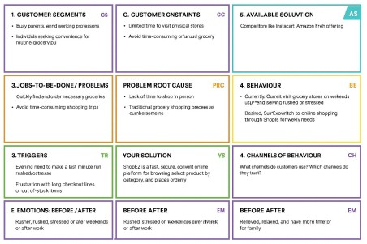
References:
- . https://www.ideahackers.network/problem-solution-fit-canvas/
- . https://medium.com/@epicantus/problem-solution-fit-canvas-aa3dd59cb4fe

